**浙大城市学院实验报告**

课程名称 计算机网络实验

实验项目名称 实验13 IPV6实验

学生姓名 专业班级 学号

指导老师 实验日期

一、实验目的

1.掌握IPV6的地址配置方法；

2.掌握IPV6的路由配置;

3.掌握IPV6隧道配置

二、实验设备

Packet Tracer模拟器软件；

Cisco 2911路由器若干台，PC机 6台。

三、实验内容

1. 静态路由实验

根据以下拓扑图，完成静态路由配置，实现全网可达，**要求将R1路由器命名为本人姓名的综写。**

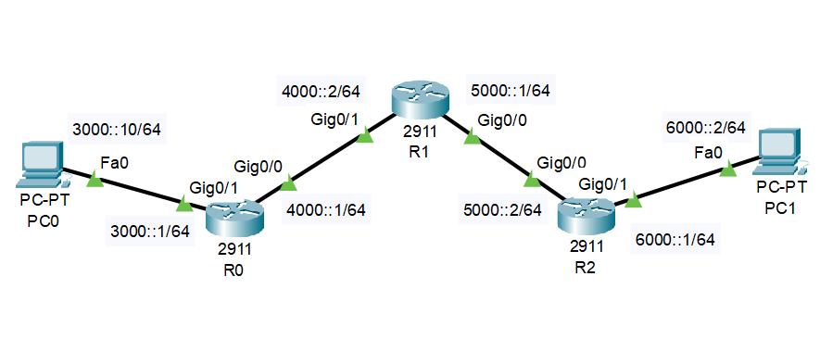

R0的配置：

|  |
| --- |
| Router>en  Router#conf t  Enter configuration commands, one per line. End with CNTL/Z.  Router(config)#hostname R0  R0(config)#interface g0/1  R0(config-if)#ipv6 address 3000::1/64  R0(config-if)#no shutdown  R0(config-if)#  %LINK-5-CHANGED: Interface GigabitEthernet0/1, changed state to up  %LINEPROTO-5-UPDOWN: Line protocol on Interface GigabitEthernet0/1, changed state to up  R0(config-if)#interface g0/0  R0(config-if)#ipv6 address 4000::1/64  R0(config-if)#no shutdown  R0(config-if)#  %LINK-5-CHANGED: Interface GigabitEthernet0/0, changed state to up  R0(config)#ipv6 unicast-routing  R0(config)#ipv6 route 5000::/64 4000::2  R0(config)#ipv6 route 6000::/64 4000::2  R0(config)# |

R1的配置：

|  |
| --- |
| Router>en  Router#conf t  Enter configuration commands, one per line. End with CNTL/Z.  Router(config)#hostname XBH  XBH(config)#interface g0/1  XBH(config-if)#ipv6 address 4000::2/64  XBH(config-if)#no shutdown  XBH(config-if)#interface g0/0  XBH(config-if)#ipv6 address 5000::1/64  XBH(config-if)#no shutdown  XBH(config)#ipv6 unicast-routing  XBH(config)#ipv6 route 3000::/64 4000::1  XBH(config)#ipv6 route 6000::/64 5000::2  XBH(config)# |

R2的配置：

|  |
| --- |
| Router>en  Router#conf t  Enter configuration commands, one per line. End with CNTL/Z.  Router(config)#hostname R2  R2(config)#interface g0/0  R2(config-if)#ipv6 address 5000::2/64  R2(config-if)#no shutdown  R2(config-if)#  %LINK-5-CHANGED: Interface GigabitEthernet0/0, changed state to up  %LINEPROTO-5-UPDOWN: Line protocol on Interface GigabitEthernet0/0, changed state to up  R2(config-if)#interface g0/1  R2(config-if)#ipv6 address 6000::1/64  R2(config-if)#no shutdown  R2(config-if)#  %LINK-5-CHANGED: Interface GigabitEthernet0/1, changed state to up  %LINEPROTO-5-UPDOWN: Line protocol on Interface GigabitEthernet0/1, changed state to up  R2(config-if)#ipv6 unicast-routing  R2(config)#ipv6 route 4000::/64 5000::1  R2(config)#ipv6 route 3000::/64 5000::1  R2(config)# |

可达性结果测试：

PC0 => PC1

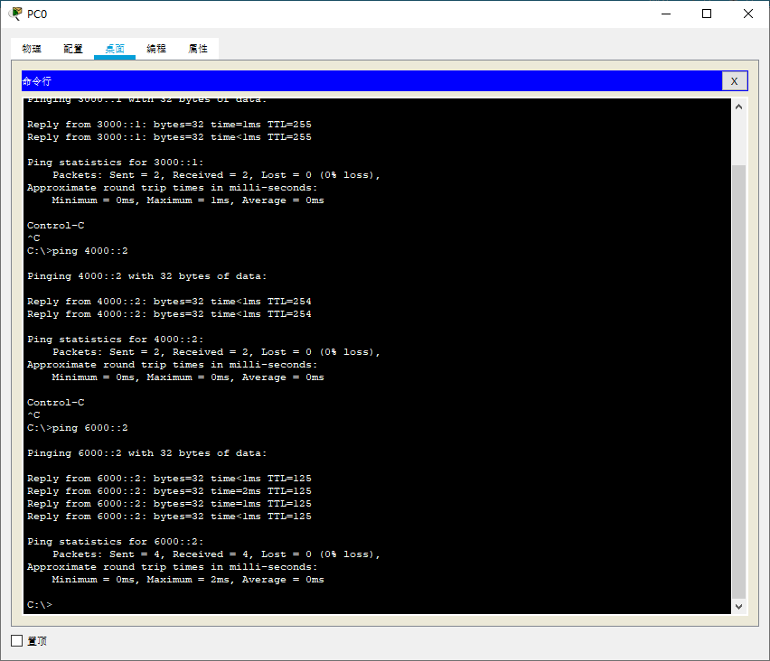

PC1 => PC0

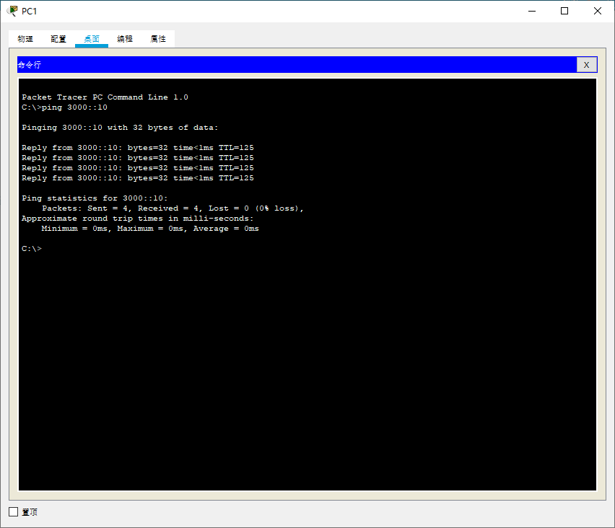

1. RIPv6实验

根据以下拓扑图，完成静态路由配置，实现全网可达，**要求将Router1路由器命名为本人姓名的综写。**

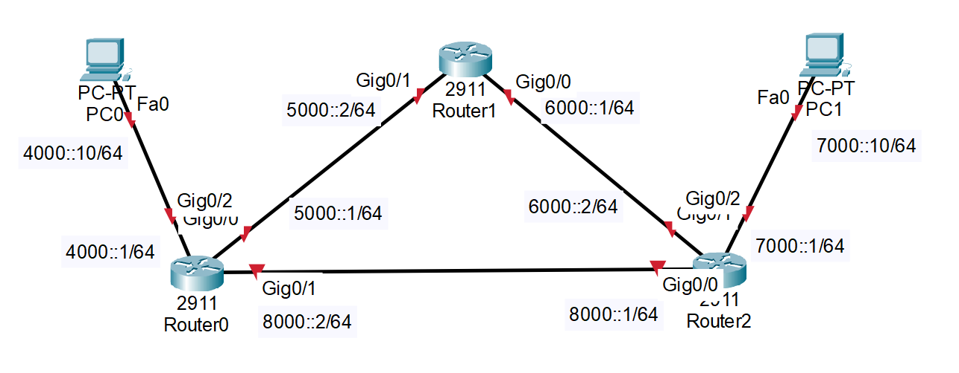

Router0的配置：

|  |
| --- |
| Router>en  Router#conf t  Enter configuration commands, one per line. End with CNTL/Z.  Router(config)#hostname R0  R0(config)#interface g0/2  R0(config-if)#ipv6 address 4000::1/64  R0(config-if)#no shutdown  R0(config-if)#  %LINK-5-CHANGED: Interface GigabitEthernet0/2, changed state to up  %LINEPROTO-5-UPDOWN: Line protocol on Interface GigabitEthernet0/2, changed state to up  R0(config-if)#interface g0/0  R0(config-if)#ipv6 address 5000::1/64  R0(config-if)#no shutdown  R0(config-if)#  %LINK-5-CHANGED: Interface GigabitEthernet0/0, changed state to up  R0(config-if)#interface g0/1  R0(config-if)#ipv6 address 8000::2/64  R0(config-if)#no shutdown  R0(config-if)#  %LINK-5-CHANGED: Interface GigabitEthernet0/1, changed state to up  R0(config)#ipv6 unicast-routing  R0(config)#ipv6 route 7000::/64 8000::1  R0(config)#ipv6 route 6000::/64 5000::2  R0(config)#ipv6 route 6000::/64 8000::1  R0(config)#ipv6 route 7000::/64 5000::2  R0(config)# |

Router1的配置：

|  |
| --- |
| Router>en  Router#conf t  Enter configuration commands, one per line. End with CNTL/Z.  Router(config)#hostname XBH  XBH(config)#interface g0/1  XBH(config-if)#ipv6 address 5000::2/64  XBH(config-if)#no shutdown  XBH(config-if)#  %LINK-5-CHANGED: Interface GigabitEthernet0/1, changed state to up  %LINEPROTO-5-UPDOWN: Line protocol on Interface GigabitEthernet0/1, changed state to up  XBH(config-if)#interface g0/0  XBH(config-if)#ipv6 address 6000::1/64  XBH(config-if)#no shutdown  XBH(config-if)#  %LINK-5-CHANGED: Interface GigabitEthernet0/0, changed state to up  XBH(config)#ipv6 unicast-routing  XBH(config)#ipv6 route 4000::/64 5000::1  XBH(config)#ipv6 route 7000::/64 6000::2  XBH(config)#ipv6 route 8000::/64 6000::2  XBH(config)#ipv6 route 8000::/64 5000::1  XBH(config)# |

Router2的配置：

|  |
| --- |
| Router>en  Router#conf t  Enter configuration commands, one per line. End with CNTL/Z.  Router(config)#hostname R2  R2(config)#interface g0/0  R2(config-if)#ipv6 address 8000::1/64  R2(config-if)#no shutdown  R2(config-if)#  %LINK-5-CHANGED: Interface GigabitEthernet0/0, changed state to up  %LINEPROTO-5-UPDOWN: Line protocol on Interface GigabitEthernet0/0, changed state to up  R2(config-if)#interface g0/1  R2(config-if)#ipv6 address 6000::2/64  R2(config-if)#no shutdown  R2(config-if)#  %LINK-5-CHANGED: Interface GigabitEthernet0/1, changed state to up  %LINEPROTO-5-UPDOWN: Line protocol on Interface GigabitEthernet0/1, changed state to up  R2(config-if)#interface g0/2  R2(config-if)#ipv6 address 7000::1/64  R2(config-if)#no shutdown  R2(config-if)#  %LINK-5-CHANGED: Interface GigabitEthernet0/2, changed state to up  %LINEPROTO-5-UPDOWN: Line protocol on Interface GigabitEthernet0/2, changed state to up  R2(config)#ipv6 unicast-routing  R2(config)#ipv6 route 4000::/64 8000::2  R2(config)#ipv6 route 4000::/64 6000::1  R2(config)#ipv6 route 5000::/64 6000::1  R2(config)#ipv6 route 5000::/64 8000::2 |

可达性结果测试：

PC0 => PC1

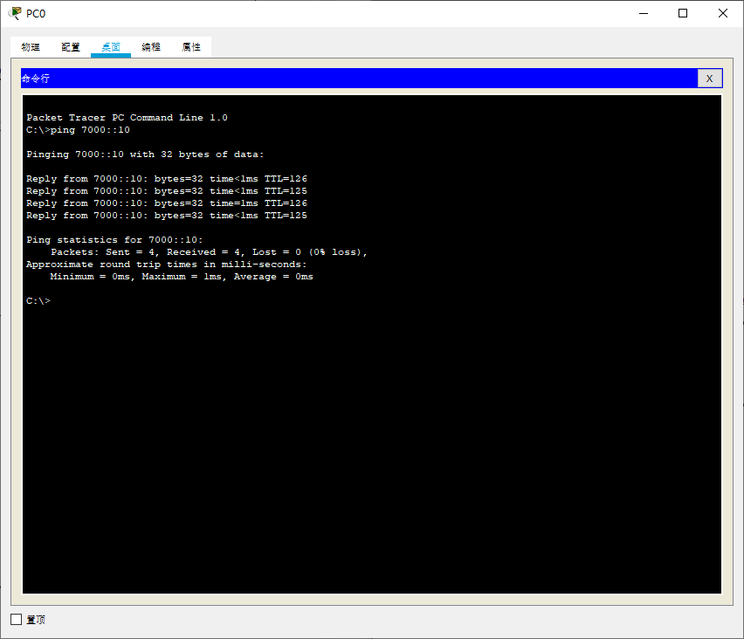

PC1 => PC0

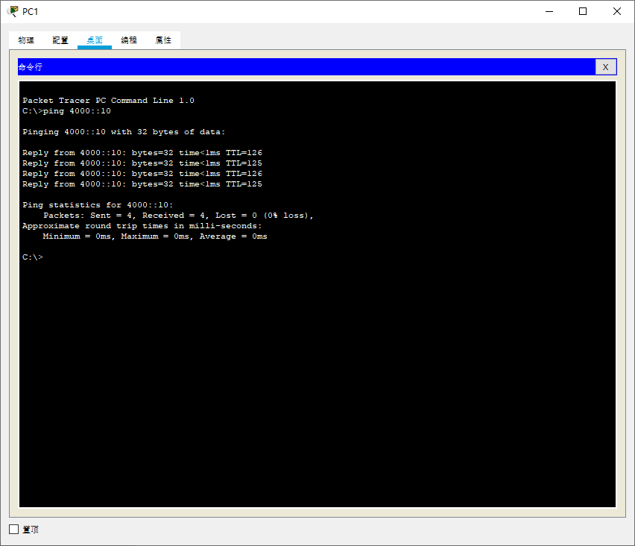

1. IPV6隧道实验

根据以下拓扑图，完成静态路由配置，实现全网可达，**要求将R2路由器命名为本人姓名的综写。**

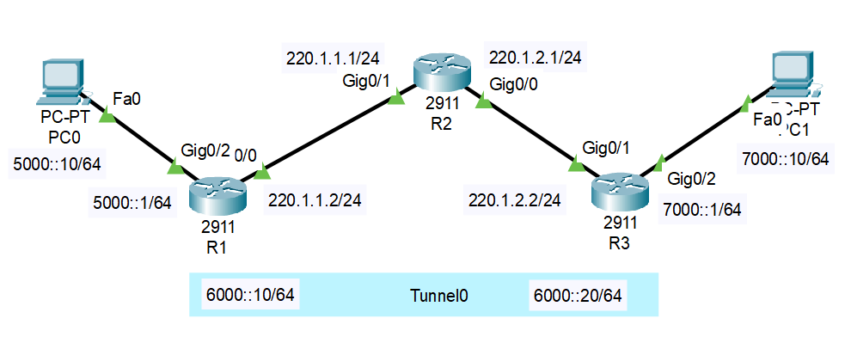

R1的配置：

|  |
| --- |
| Router>en  Router#conf t  Enter configuration commands, one per line. End with CNTL/Z.  Router(config)#interface g0/0  Router(config-if)#ip address 220.1.1.2 255.255.255.0  Router(config-if)#no shutdown  Router(config-if)#  %LINK-5-CHANGED: Interface GigabitEthernet0/0, changed state to up  Router(config-if)#interface g0/2  Router(config-if)#ipv6 address 5000::1/64  Router(config-if)#no shutdown  Router(config-if)#  %LINK-5-CHANGED: Interface GigabitEthernet0/2, changed state to up  %LINEPROTO-5-UPDOWN: Line protocol on Interface GigabitEthernet0/2, changed state to up  Router(config-if)#interface Tunnel 0  Router(config-if)#  %LINK-5-CHANGED: Interface Tunnel0, changed state to up  Router(config-if)#ipv6 address 6000::10/64  Router(config-if)#tunnel source g0/0  Router(config-if)#tunnel destination 220.1.2.2  Router(config-if)#tunnel mode ipv6ip  Router(config-if)#exit  Router(config)#ipv6 unicast-routing  Router(config)#ipv6 route 7000::/64 6000::20  Router(config)#ip route 0.0.0.0 0.0.0.0 220.1.1.1  Router(config)# |

R2的配置：

|  |
| --- |
| Router>en  Router#conf t  Enter configuration commands, one per line. End with CNTL/Z.  Router(config)#hostname XBH  XBH(config)#interface g0/1  XBH(config-if)#ip address 220.1.1.1 255.255.255.0  XBH(config-if)#no shutdown  XBH(config-if)#  %LINK-5-CHANGED: Interface GigabitEthernet0/1, changed state to up  %LINEPROTO-5-UPDOWN: Line protocol on Interface GigabitEthernet0/1, changed state to up  XBH(config-if)#interface g0/0  XBH(config-if)#ip address 220.1.2.1 255.255.255.0  XBH(config-if)#no shutdown  XBH(config-if)#  %LINK-5-CHANGED: Interface GigabitEthernet0/0, changed state to up  %LINEPROTO-5-UPDOWN: Line protocol on Interface GigabitEthernet0/0, changed state to up |

R3的配置：

|  |
| --- |
| Router>en  Router#conf t  Enter configuration commands, one per line. End with CNTL/Z.  Router(config)#hostname R3  R3(config)#interface g0/1  R3(config-if)#ip address 220.1.2.2 255.255.255.0  R3(config-if)#no shutdown  R3(config-if)#  %LINK-5-CHANGED: Interface GigabitEthernet0/1, changed state to up  R3(config-if)#interface g0/2  R3(config-if)#ipv6 address 7000::1/64  R3(config-if)#no shutdown  R3(config-if)#  %LINK-5-CHANGED: Interface GigabitEthernet0/2, changed state to up  %LINEPROTO-5-UPDOWN: Line protocol on Interface GigabitEthernet0/2, changed state to up  R3(config-if)#exit  R3(config)#interface tunnel 0  R3(config-if)#  %LINK-5-CHANGED: Interface Tunnel0, changed state to up  R3(config-if)#ipv5 address 6000::20/64  ^  % Invalid input detected at '^' marker.  R3(config-if)#ipv6 address 6000::20/64  R3(config-if)#no shutdown  R3(config-if)#tunnel source g0/1  R3(config-if)#tunnel destination 220.1.1.2  R3(config-if)#tunnel mode ipv6ip  R3(config-if)#ipv6 unicast-routing  R3(config)#ipv6 route 5000::/64 6000::10  R3(config)#ip route 0.0.0.0 0.0.0.0 220.1.2.1  R3(config)# |

可达性结果测试：

PC0 => PC1

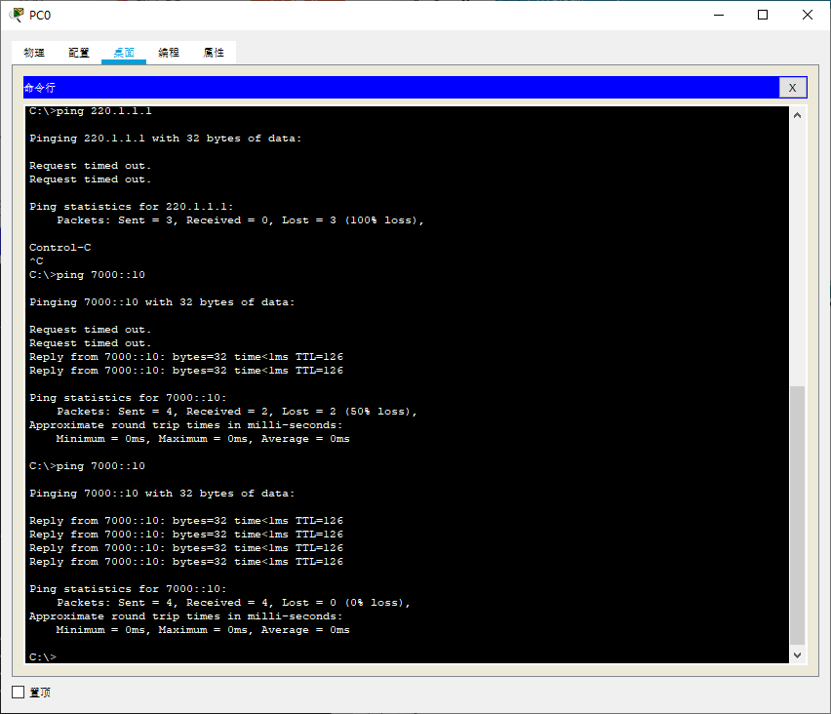

PC1 => PC0

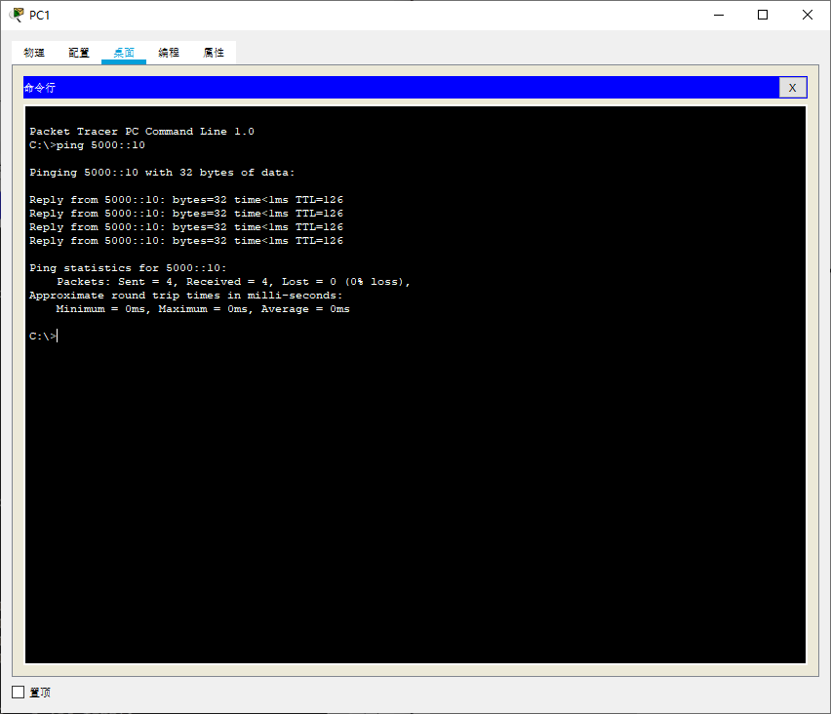

五、收获感想：

记录实验感受、操作过程中遇到的困难及解决办法、遗留的问题、意见和建议等。

学习到了ipv6路由表的配置以及ipv6隧道的配置